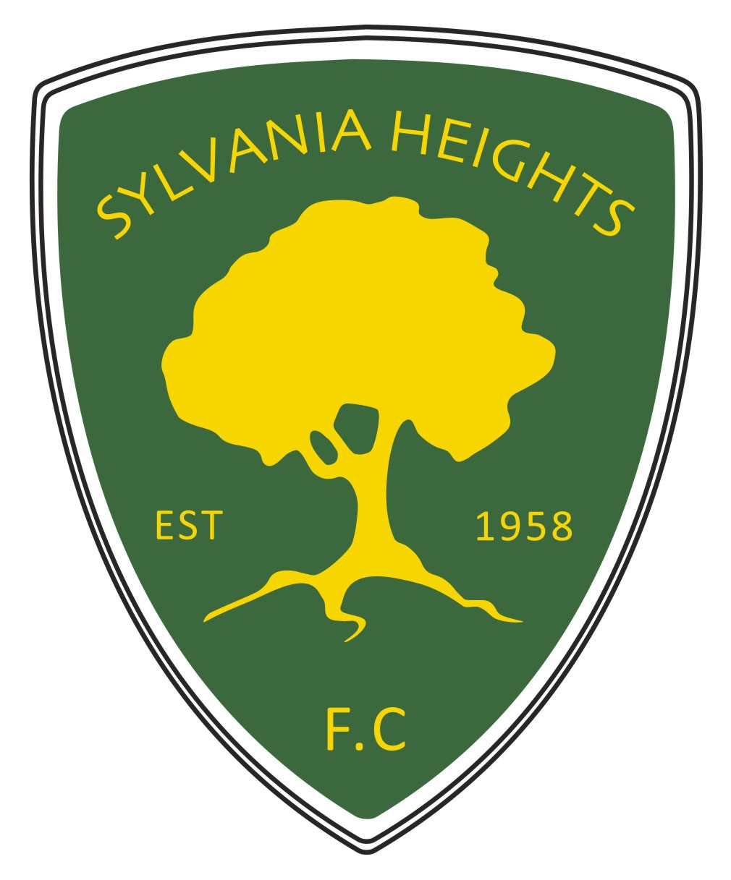
Sylvania Heights Community & Youth Club Inc
A.B.N. 1122 126 0063
Sylvania Heights Football Club
Post Office Box 453
Southgate, Sylvania, NSW 2224

SYLVANIA HEIGHTS FOOTBALL CLUB
UNDER 8’s GALA DAY
SUNDAY 13 AUGUST 2023

We wish to enter the following team in the Sylvania Heights FC Under 8’s Gala Day being held on Sunday 13 August 2023
ALL ENTRIES CAN BE COMPLETED ONLINE

To ENTER follow link:
https://www.ssfaservices.com.au/events/category/Gala-Days/

In you are unable to enter online:
Please return this completed entry form before 3pm Fri 21 Jul 23 by email to: sylvaniaheightsfc@ssfaservices.com.au

YOUR CLUB: …………………………………………………………………………………
COMPETITION REQUESTED ……………………………………………………………
TEAM GRADE:………………………………………….
NUMBER OF TEAM PLAYERS:……………..
TEAM CONTACT NAME:……………………………………………………………………………….
TEAM CONTACT PHONE No:……………………………………………………………………….
TEAM CONTACT EMAIL:………………………………………………………………………………………………
PLEASE NOTE THAT ALL CORRESPONDENCE WILL BE VIA EMAIL.
The entry fee is $200.00 per team and payment should only be made ONCE CONFIRMATION OF PARTICIPATION is received from the Gala Day Entries Co-ordinator – payments to be made to: Sylvania Heights Community & Youth Club Inc.
Bank: CBA. BSB: 062 184
Account Number:1006 1190
Reference: Insert Your Club & Team grade

Please identify teams and Clubs with payment so we can match up entry fees.
All enquiries and applications should be directed by email to Shared Services at SSFA who run the Gala Day Entries on our behalf: sylvaniaheightsfc@ssfaservices.com.au or phone 9542 3577 and ask for Shared Services.
We look forward to teams from your Club participating on the day. Be advised that no entry fee refunds will be made should your team pull out of the Gala Day within 14 days of it.

