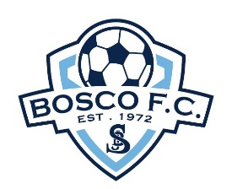 | BOSCO  FOOTBALL CLUB

U9 Gala Nights Series | 2021

Bosco Football Club warmly extends an invitation to all U9’s teams across the Sutherland Shire and beyond to participate in our annual U9 Gala nights.

- The Jack Bird Trophy: Scheduled for Friday 21 May 2021 - Offers quality fun for all under 9 teams C grade and lower.

- Speedy Keys Girls Cup: Scheduled for Friday 16 July 2021 - Is for all under 9 girls teams and invited under 8 girls teams.

- The Bill Charlton Champion’s Cup: Scheduled for Friday 16 July 2021 - Is best suited for under 9 teams A and B graded teams.

Location: Woronora Heights Oval 69 Willaroo Road, Woronora Heights NSW 2233 with kick off at 5:30pm sharp. Each team being guaranteed four games on the night with the evening usually concluding at approx. 8:30pm – 9:00pm.

Entry Fee: $100.00 per team payable by;
- Cheque made out to: Bosco Football Club, posted to at P.O. Box 480 Engadine NSW 2233 care of the Bosco FC Treasurer or;
- EFT to: Bosco Football Club BSB: 062164 and Account Number: 00902923. Please ensure you label payment with Club & Team names.

The first 20 teams to apply for each Gala will secure a starting place in these nights. Every player will receive a commemorative participation medallion.

Please complete the relevant entry form email to:

Primary Contact: Kalina Ford - kalinaford@gmail.com

Secondary Contact: David McCann – 0417 409 588 – president@boscofc.org.au

