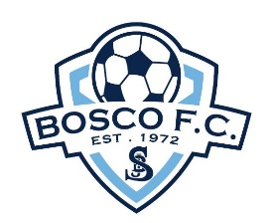 | BOSCO  FOOTBALL CLUB

2021 Under 9’s Gala Night

SPEEDY KEYS GIRLS CUP Entry Form

Friday Night 16 July 2021 at 5:30pm

Name of Club
Name /Grade of Team

Our nominated players for the above team registration are listed below:

Player’s Name | Date of Birth | SSFA Player Identification Number  (Available from Club Registrar and may be submitted following application form closer to the Gala Night).
1.
2.
3.
4.
5.
6.
7.
8.
9.
10.

We acknowledge:
- 10 players maximum may be registered to play in any one team.
- Players cannot be registered to play in more than one team.
- Only players nominated via this official entry form are eligible to play in the Gala Night.
- Clubs are not permitted to borrow players between teams participating in the Jack Bird Trophy or from teams participating in the Bill Charlton Champion’s Cup, regardless of how many teams from one Club have been registered to play or of any one team’s standing in either competition.

 | Name | Email | Phone
Team Coach
Team Manager
Club Secretary

We acknowledge that our team payment will follow via post, our application which has been lodged via email.

Entry Fee: $100.00 per team payable by;
- Cheque made out to: Bosco Football Club, posted to at P.O. Box 480 Engadine NSW 2233 care of the Bosco FC Treasurer or;
- EFT to: Bosco Football Club BSB: 062164 and Account Number: 00902923.

Please ensure that your cheque or EFT payment indicates what Club & Team you’re from.

A copy of the rules and spirit of play will be forwarded to your team upon receipt of your application form. A draw will be emailed to you closer to the Gala Night. Both Coaches and managers will be required to sign and abide by a Code of Conduct across both nights.

